[THESIS TITLE IN ALL CAPS, CENTERED (NOT JUSTIFIED OR DISTRIBUTED),
LOGICALLY DISTRIBUTED IF MORE THAN ONE LINE]

A Thesis
Presented to
the Faculty of California Polytechnic State University,
San Luis Obispo
In Partial Fulfillment
of the Requirements for the Degree
Master of [Degree Title] in [Program Title]
by
[Student Name]
[Publication Deadline Month Year]

© [Year Submitted]

[Writer’s Full Name]

ALL RIGHTS RESERVED
COMMITTEE MEMBERSHIP
TITLE: |  | [Thesis Title in Title Case; wording must match the Title Page]
AUTHOR: |  | [Student’s Full Name]
DATE SUBMITTED: |  | [Publication Deadline Month Year]
COMMITTEE CHAIR: |  | [Jane Smith, Ph.D.]  [Professor of Biomedical Engineering]
COMMITTEE MEMBER: |  | [Full Name, Degree]  [Full Faculty Title]
COMMITTEE MEMBER: |  | [Full Name, Degree]  [Full Faculty Title]
ABSTRACT
[Thesis Title in Title Case; wording must match the Title Page]

[Student’s Full Name]

[Begin the abstract text here. The abstract must be double-spaced.]

Keywords: [machine learning, Traveling Salesperson Problem, TSPLIB, approximation algorithms, C++].
ACKNOWLEDGMENTS

[This page is optional. If included, use it to acknowledge individuals, organizations, or funding sources that contributed to or supported your research. If you do not wish to include acknowledgments, delete this page. If acknowledging only one person, change the heading to ACKNOWLEDGMENT.]

TABLE OF CONTENTS
Page
LIST OF TABLES [if applicable] vii
LIST OF FIGURES [if applicable] viii
CHAPTER
1. [INTRODUCTION] 1
1.1 [Statement of Problem] 1
1.2 [Research Questions and Scope of the Study] 3
1.3 [Purpose of Study] 5
2. [LITERATURE REVIEW] 8
2.1 [Background and Previous Approaches to Sustainable Design in Applied Engineering Research and Validation Environments] 8
2.1.1 [Previous Experimental Methods and Measurement Approaches] 10
2.2 [Current Research Gaps] 12
2.2.1 [Summary of Prior Findings] 14
3. [CONCLUSION] 40
REFERENCES 45
APPENDICES
A. [Survey Instrument] 48
B. [Additional Experimental Results] 52

LIST OF TABLES
Table Page
1. [Table titles should match the corresponding titles exactly as they appear in the thesis, including wording and capitalization. A multi-line entry may be single-spaced; maintain double spacing between separate entries.] 1
2. [Experimental Conditions and Measurement Parameters Used Across All Study Phases and Validation Environments.] 3
3. [Participant Demographics.] 8

LIST OF FIGURES
Figure Page
1. [Figure captions should match the corresponding captions exactly as they appear in the thesis, including wording and capitalization. A multi-line entry may be single-spaced; maintain double spacing between separate entries.] 2
2. [Comparison of Measured and Predicted Performance Across Multiple Testing Conditions and Validation Trials.] 5
3. [Experimental Setup.] 9

Chapter 1
[INTRODUCTION]
[Begin your thesis text here. Heading formatting, capitalization, and emphasis (e.g., bold or italics) may be customized, provided they are applied consistently throughout the thesis. Table titles and figure captions may also use consistent formatting choices.]
1.1 [Sample Section Heading]
[Continue your body text here. The examples below demonstrate basic table and figure placement.]
Table 1. [Sample Table Title]. [Table titles may be single-spaced.]
Category | Value
Sample A | 10
Sample B | 20

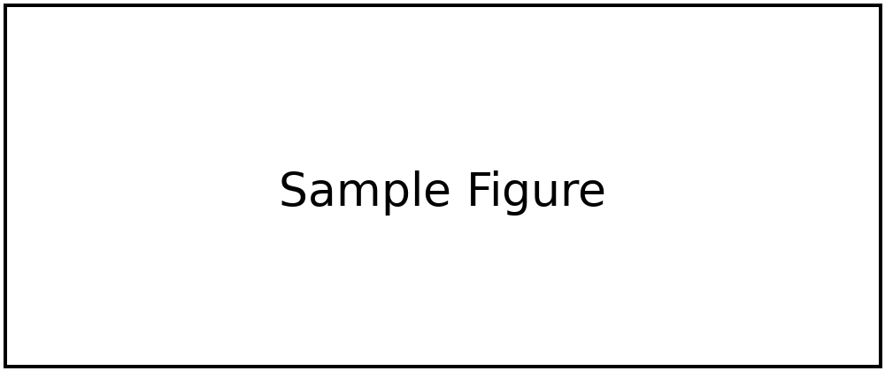
Figure 1. [Sample Figure Caption]. [Figure captions may be single-spaced.]
[Continue your thesis text here. Leave at least one blank line between the figure caption and the text that follows.]
REFERENCES
[1] [Use the citation style guide recommended by your program. If references are not numbered, list them alphabetically. Multi-line reference entries may be single-spaced; maintain double spacing between separate entries. Keep each reference entry together on one page. URLs may remain clickable but should appear in black text and not be underlined.]
[2] [Nguyen, T. R., Patel, S., and Chen, L. Evaluating adaptive control strategies across distributed sensor networks: Methods, validation, and implementation considerations. Journal of Applied Systems Engineering, 14(3), 211-229, 2024. https://example.org/research/adaptive-control]
[3] [Smith, J. A., and R. Lee. Example journal article title. Journal of Applied Research, 18(2), 101-118, 2025.]

Appendix A
[SURVEY INSTRUMENT]

[Begin appendix content here.]

Appendix B
[ADDITIONAL EXPERIMENTAL RESULTS]

[Begin appendix content here.]

